Estuary and Gulf of St. Lawrence: Temperatures, Salinity, and Fish Populations

# Motivation

Our proposed project was to use Argo data (a data set of ocean floats that collect variables such as salinity and temperature in oceans around the world), map the change of salinity and temperature in the Estuary and Gulf of St. Lawrence, and identify potential correlations to fish populations totals in the same area.

The Estuary and Gulf of St. Lawrence (the “Gulf”) is an incredibly diverse and complex marine and estuary ecosystem and is one of the largest of its kind in the world. The area is made up of freshwater from the Canadian Shield, the Great Lakes basin and the St. Lawrence River system emptying out into the Atlantic Ocean, where it combines with the cold Labrador Current from the Arctic and the warm Gulf Stream from the tropics. These currents merge in a semi-enclosed and mostly shallow area, creating perfect conditions for an incredible diversity of life. The Gulf is the most important source of fish on the Atlantic side for the commercial fishing industry in both the U.S. and Canada, both top exporters of fish and seafood in the world[1]. By studying and reporting about this ecosystem and the species that depend on it, we hope to better inform others about its critical importance.

This project aimed to answer the following questions:

* How have ocean properties such as temperature and salinity changed over a period of ten years in the Gulf?
* How have pelagic fish populations changed in the Gulf within the same time period?
* Is there a meaningful correlation between ocean properties and fish population evolutions that merits further study?

# Data Sources

## Argo Data

Argo is an international program that collects information about Earth’s oceans using a fleet of robotic instruments that drift with the ocean currents and move between the surface and mid-water level. For the scope of this project, we used Atlantic Ocean data between latitude 38 to 59 and longitude -70 to -35 (corresponding to a large zone including the St Lawrence Gulf).

### **Name**: Argo float data and metadata from the Global Data Assembly Centre (Argo GDAC) –Atlantic Ocean, 2009-2019

### **Data Location**: <ftp://usgodae.org/pub/outgoing/argo>

### **Format**: netCDF files (one per day)

### **Important variables**: Float identifier, depth, salinity, temperature, adjusted salinity, adjusted temperature (based on scientific calculations), quality flags, latitude and longitude. Date is derived from each file name.

### **Time period used**: 2009-2019

### **Size**: 36.8 GB (before pre-processing)

### **Total records**: 626,703 (post pre-processing)

### **Access method**: Files were downloaded from the FTP site, then records were pre-processed and stored in a relational database (AWS RDS).

## Global Temperature and Salinity Profile Programme Data

Based on an initial exploration of the Argo dataset, it became quickly clear that the dataset might be relatively sparse on float data within the Gulf itself. Data from the Global Temperature and Salinity Profile Programme (GTSPP), a joint international cooperative effort supporting the World Climate Research Programme, was used to supplement Argo data for the same time period (2009-2019). Similar to Argo data, GTSPP data also collects sea measurements such as salinity and temperature in the Earth’s oceans, but instead of floats, data is collected from both ships and buoys. Measurements are not quite as deep as Argo data, as depth measurements max out before a thousand meters.

### **Name:** Global Temperature and Salinity Profile Programme (GTSPP) data

### **Data Location**: <ftp://ftp.nodc.noaa.gov/pub/data.nodc/gtspp/best_nc/>

### **Formats**: individual netCDF files aggregated in a monthly tarball

### **Important variables contained in each file**: latitude, longitude, station or ship identifier, timestamp of measurement, depth of measurement (in meters), salinity, and temperature. Supplementing all these measurements are additional measurements denoting the quality of the measurement (e.g., ‘good’, ‘probably good’, ‘probably bad’, etc.).

### **Time period used**: 2009-2019

### **Size**: 132 tar.gz files, 7.83 GB (compressed)

### **Total records**: 43,573 (post pre-processing)

## Government of Canada’s Department of Fisheries and Oceans (DFO) – Quebec Coastal Thermograph Network

DFO’s dataset was used to supplement both the Argo float and GTSPP dataset at the surface level, as we were not sure we would have sufficient measurement points for the Gulf from the first two datasets. Data are collected from buoys and, unlike both Argo and GTSPP data, strictly surface level data only (less than 100 meters).

### **Name**: Department of Fisheries and Oceans (DFO) - Quebec Coastal Thermograph Network

### **Data Location**: <https://open.canada.ca/data/en/dataset/848e943b-1a98-43b8-acb3-ac89af17ea41> (HTTP access)

### **Formats Used**: a zipped file containing 2 folders, 1 with CSV files of each station and another folder with graphs.

### **Important variables contained in each file**: Timestamp of measurement, station id, latitude, longitude, depth of measurement, temperature and salinity.

### Time period used: 2009-2019

### **Total records**: 158,764 (post pre-processing)

## Government of Canada’s Department of Fisheries and Oceans (DFO) – Pelagic Fish Populations in the Gulf

The Canadian Department of Fisheries and Ocean conducts annual multidisciplinary surveys of the Northern and Southern Gulf of St. Lawrence to capture information on groundfish and invertebrates’ abundance, spatial distribution and diversity. The pelagic species represented in the dataset are: Arctic Cod, Atlantic Argentine, Atlantic Herring, Atlantic Mackerel, Atlantic Soft Pout, Capelin, Lumpfish, Pollock, Rainbow Smelt, Sand Lances, Silver Hake, Three-spined Stickleback and White Barracudina.

### **Name**: Pelagic fish species abundance in the Estuary and Gulf of St. Lawrence between 2009 and 2018

### **Data Location**: <https://open.canada.ca/data/en/dataset/f1fc359c-0ed1-4045-a421-adef2497b68d>

### **Formats Used**: a zipped file containing 2 CSV files from http download, one for each regional location.

### **Important variables contained in each file**: Date of measurement, the station id, latitude, longitude, and quantity of specific fish species.

### Time Periods Covered: 2009 - 2018

### **Size**: approx. 1,700 lines of data per file (0.2MB zipped)

### **Access method**: HTTP download and from relational database post processing

### **Total records**: 41,145 (post pre-processing)

## Estuary and Gulf of St. Lawrence Shape File

A private label shape file denoting the boundaries of the Gulf and Estuary of St. Lawrence.

### **Name**: Gulf of St. Lawrence shapefile

### **Short Description**: Shapefile of the Gulf and Estuary of St. Lawrence for visualization purposes.

### **Size**: <1MB

### **Location**: <https://www.marineregions.org/gazetteer.php?p=details&id=4290>

### **Format**: Shapefile

### **Access method**: Downloaded and stored in GitHub repository. Opened and manipulated with Python’s shapely and pyshape.

Below is the architecture of our live application.

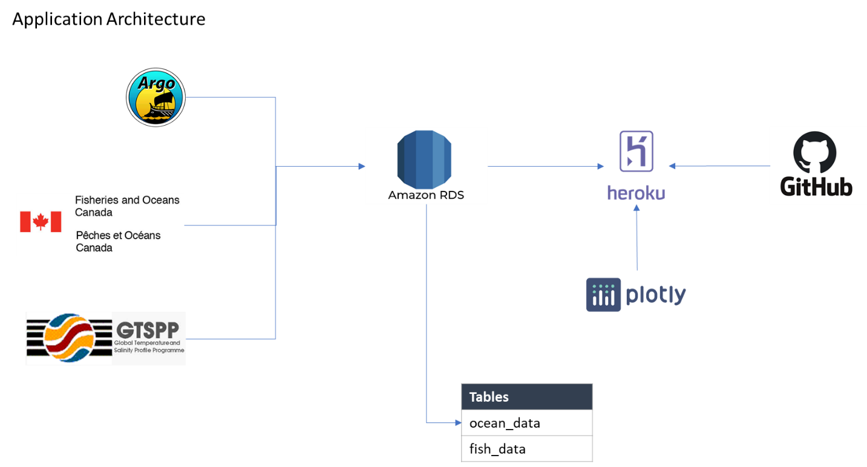

# Data Manipulation

## Data helpers/packages (files are located in the /helper folder)

Since our datasets are quite large and not conducive towards local Jupyter manipulation at large, our data processing and manipulation jobs were chunked and we used several helpers and processes to move data for cleanup and visualization.

### db.py: Since our data is stored in AWS RDS, a helper was written to move data to and from the databases. We chose to use PostgreSQL as our underlying database and the psycopg2 python package to read from and write to the database. The helper file covers:

1. Executing queries from AWS (*run_query()*): Executing and returning basic SQL queries for Jupyter exploration and use. Typical SELECT statements will return in pandas dataframe format for immediate exploration and use. *run_query()* can also be used to execute basic statements with no data returns, e.g., ALTER TABLE statements. For this project, *run_query()* is relatively generic and does not allow for iterated/chunked returns.
2. Inserting dataframes: The *db* helper leverages the use of pandas *to_sql()* although Postgres only works with that particular method in a very limited way. It works for bulk insert as long as there are no collisions on keys.
3. Upserts (labeled *upsert()*): A method used for slightly more specialized dataframe rows inserts (replace on collision with keys). Quite slow as it uses a single connection per dataframe row, but useful to update specific rows while keeping keys in place. Further optimization was not needed for this project.
4. Formatting strings: Some internal methods are built in to format items inside a dataframe (e.g., *_val_format()*, *_clean_df()*). This is used to build SQL query strings easily.
5. *database_demo.ipynb* in the */notebook* folder runs through how it can be used.

### spkly: A helper package written as extra credit for SIADS 521 that creates tiny sparklines for dataframes columns when using *spkly.display(df)*. It is meant to be extremely lightweight and allows visualization of a dataset quickly without requiring writing additional matplotlib code.

## Argo

### Each netCDF file contained several variables encoded in different ways. After selecting the variables we needed for our analysis, we had to unmask and decode their data. Cleaned data was then loaded into a dataframe.

### The Atlantic data files cover a wide area (the Atlantic ocean!), but we did not need the full dataset for our analysis. We filtered the data to retain only points with a latitude between 38 to 59 and a longitude between -70 to -35 (corresponding to a large zone including the Gulf).

### The date column was created based on the netCDF file name, which contains the date the measures were published to the FTP site. There is a slight delay between publication date and measuring date as measures are reviewed by the scientific community. For the purpose of our project, we considered a week of delay would not significantly impact our analysis of parameter variation since water temperature and salinity are unlikely to drop or increase drastically in such a short period of time.

### Argo data stores one entry per float, but each float captures multiple data points as they rise to the surface. Once the dataframe was created, we had to unnest the parameters variables (temperature, temperature adjusted, salinity, salinity adjusted) to create one record for each measure.

### Parameters variables in Argo data are meant to contain up to 2170 values. When a float only goes down to 1000m, only 1000 values are filled in the netCDF schema and the remaining values are set to 99999.00 (default value). We removed the default value to only keep recorded measures. Then, when the parameter (temperature or salinity) had been adjusted, we kept the adjusted record instead of the initial record as our value, taking advantage of the processing done by the scientific community before publication.

### Depth was not included in the dataset, but pressure in decibar was recorded. After confirming with a oceanography expert, we used the pressure in decibar as depth in m: Because a one-metre (three-foot) column of seawater produces a pressure of about one decibar (0.1 atmosphere), the pressure in decibars is approximately equal to the depth in metres.[2]

### We then binned the data by depths to be measure trends across meaningful intervals (e.g. 0-100m, 100-200m).

### To avoid timeout and disconnections from the FTP site, each file was downloaded locally, pre-processed then wrote to the ocean_data database. We used Python’s *time.sleep()* function to work around time outs and do all the upload at once. We also leveraged try/except capabilities to handle cases where we do not have data to write to the database from a file (two files that did not contain float data within our chosen latitude and longitude).

### An additional processing step was done after the data was uploaded to the ocean_data table to check that the data was within the Gulf. The ETL and update process is stored in /notebooks/argo_mapper.py, which contains both the shape lookup and the accompany upsert.

Our final pipeline for pre-processing the data included the following steps:

* Download file
* Process file:
  + *unmask_variables()*
  + *select_columns()*
  + if we had data to write (i.e. our dataframe is of length >= 1): *unnest_param()*, *depth_bins()*
  + *insert_table(‘ocean_data’, file)*

## GTSPP Data

### **How specifically did you need to manipulate the data?** Measurements were stored in netCDF format, an array-based file format, which in turn were zipped and aggregated on a monthly basis. Each file contains a set of measurements (e.g., salinity, temperature) at a single latitude/longitudinal point at varying depths, along with quality measurements. The monthly files were retrieved from an FTP via a python script in the /notebooks folder (gtspp_extraction.py) and dumped into the /data/gtspp folder. For the period 2009 to 2019, 132 tarballs were downloaded, at approximately 7.8 GB in size while still zipped.

### **How did you handle missing, incomplete, or incorrect data?** All measurements came with a quality measurement ranging from 0-9: 0 meant no quality control was performed, 1 meant the data was good, 2 meant ‘probably good,’ 3, ‘probably bad’, and so on and so forth. For quality control, only measurements that returned a quality measurement of 1 (data was considered ‘good’) was used at the very end of the process.

### **How did you perform conversion or processing steps?** Each tarball was unpacked into a subfolder in the /data/gtspp folder. Each netCDF file was opened and its latitude and longitude point extracted. Because GTSPP files covered the entire Atlantic, each latitude/longitude point was checked via pyshp/shapely to see if it was within the Estuary and Gulf of St. Lawrence (the shapefile contains latitude/longitude coordinates of this shape). If the data point was within the boundaries, then the remaining variables were unpacked from the netcdf as masked arrays and then joined together into a dataframe. Later in the ETL process, certain variables had to be transformed to human readable data – e.g., measurement time, for example was stored in a day format most likely used to convert to date properly in Excel and therefore had to be converted via Timestamp() to datetime format.

### **What variables and steps did you use to join the data resources to perform your data analysis?** The initial ‘join’ across data sets was via the Gulf shapefile – as long as they fell within this shapefile, all points were included. A secondary join to the fish population file was by year, to join fish population figures to temperature/salinity averages by year.

### **Briefly describe the workflow of your source code and what the main parts do.** The entirety of the ETL is stored in the gtspp_extraction.py for GTSPP data. The process was:

#### Download tarfiles from the FTP to /gtspp folder (­*get_data()*)

#### Unpack each individual file to a subfile, iterate through the file contents checking for measurements done within the Gulf. Once every file was examined within the tarfile, the folder was deleted in interests of space. (done via *extract_to_folder()*)

#### Qualifying measurements were unpacked and appended to a csv file named after the tarfile, stored in the data/gtspp/csv_results file. Measurement times were converted to datetime and the results were inserted into the gtspp table in the AWS RDS database (done via *raw_database_dump()*).

#### Data cleaning was done by pulling down the files from the gtspp table, grouping each measurement time into depth bins of 100 meters each and averaging the temperatures and salinity measurements within each bin. Final results were uploaded into the ocean_data table (done via *cleaned_database_dump()*).

#### Overall statistics: 132 tarfiles from FTP with 15.8 milllion latitude/longitude measurement files. Of the 15.8 million files examined, approximately 26,745 files with 1.6 million data points qualified and were uploaded to the gtspp database. After clean up and aggregation, 43,500 measurements were added to the final ocean_data table.

### **What challenges did you encounter and how did you solve them?** Mostly spotchecking to make sure the cleanup was performing as expected – was the shapefile check truly returning accurate latitude/longitude points? This was solved simply by spotchecking via a visualization – mapped all 91k points in a single file in folium and spot checked the qualifying latitude/longitude points that were returned by the script. The other challenge was largely related to file cleanup as the script ran when processes didn’t give up control of a folder – this would throw an error and end the script (as intended – didn’t want to leave unpacked tarfiles around). This was mostly solved in a rather trivial way – adding time.sleep() to specific areas to allow processes time to close out.

### **How to access the data?** Raw data can be downloaded via the script from get_data(), and sample data used in our visualization can be found in AWS RDS using SELECT * from gtspp LIMIT 10;

## Department of Fisheries and Oceans (DFO) – Quebec Coastal Thermograph Network

### **How specifically did you need to manipulate the data?**Like Argo and GTSPP data, DFO data contains measurements at a single latitude/longitudinal point of temperature and salinity. Because the data is coastal in nature within the Gulf, depth measurements are quite shallow (<100 meters).

### **How did you handle missing, incomplete, or incorrect data?** Rows with missing salinity or temperature values were simply dropped.

### **How did you perform conversion or processing steps?** The zipped file contains multiple csv files of different areas with measurements; the script runs through each and every one and aggregates them into a single dataframe table. The raw files were uploaded in aggregate to the dfo_quebec table. From the aggregate, missing data values were discarded and then the remaining data set filtered for the appropriate time ranges (2009-2019).

### **What variables and steps did you use to join the two data resources to perform your data analysis?**Because this dataset was already specific to the Gulf region, a latitude/longitude check of the measurements was not necessary. The data was aggregated and averaged together with the other remaining data sources by year and then joined against the fish population dataset by year, however.

### **Briefly describe the workflow of your source code and what the main parts do.**

#### The entirety of the ETL is done in /notebooks/oceans_fisheries_nc_extraction.py.

#### Extract_raw() opens the zip file and opens every .csv file into a dataframe and renaming columns. Raw values are dumped in the dfo_quebec table in the AWS RDS database.

#### Clean_data() cleans the full dataframe, which has aggregated all the csv files together. Rows with missing values are discarded and then further filtered for the appropriate time. Values are binned by depth bins of approximately 100 meters each and averaged by the date of the timestamp before being uploaded to the ocean_data database.

#### Overall statistics: Within the zip file: 42 csv files of approximately 8 million rows of data. After discarding missing measurements and filtering by date, 1.5 million rows were left. After cleanup and aggregation, approximately 150k rows of data were left and uploaded into ocean_data.

### **What challenges did you encounter and how did you solve them?** Timestamps in this appear to be across a single day rather than there being one set of measurements per date. In order to aggregate by date and not by datetime, I simply recasted the datetime to date before performing any aggregate calculations.

## Pelagic Fish Populations in the Estuary and Gulf of St. Lawrence

### **How specifically did you need to manipulate the data?**

### **How did you handle missing, incomplete, or incorrect data?**  For this particular dataset, no datapoints were missing, but there were many points where population points were recorded as 0 in a given area. For the purposes of overall averages, we considered these null points.

### **How did you perform conversion or processing steps?**

#### As every latitude/longitude point contain a measurement for each fish, the specific fish species columns were melted down so every measurement at a specific latitude and longitude contained one measurement for one fish species.

#### For final processing into the visualization, a SQL query aggregating these results by year and averaged were produced.

### **What variables and steps did you use to join the two data resources to perform your data analysis?**

#### Fish population data was averaged by year and joined against temperature/salinity averages by year.

### **Briefly describe the workflow of your source code and what the main parts do.**

#### The data exploration and ETL process is stored in the /notebooks/pelagic_analysis.ipynb file. The first couple of cells are exploring the data and putting it together to map and view. The spkly helper is used to get an idea about the variables.

#### The files were retrieved from the zipped file. Data is stored in 2 csv files, each containing fish population information for the north and south regions of the Gulf. The fields are the same for both, so the files were appended together. For fish names, the corresponding data dictionary was opened to remap the fish variable names to fish species name, and then further renamed to make it easier to search in a database.

#### Because each row reports a population count for all fish species at a specific longitude/latitude, the dataframe was melted down so every row would report a single value for a single species at a specific latitude/longitude (to make sql queries and dataframe filtering easier). The code for the melting, renaming, and push to database is in the cell after the folium map.

### **What challenges did you encounter and how did you solve them?**

#### Nothing major for this particular dataset.

## Estuary and Gulf of St. Lawrence Shape File

We used a shapefile as a filter/part of the cleaning process for our datasets and therefore did not process the shapefile itself.

One particular conversion of the shapefile was required, however – we converted the shapefile to its geojson equivalent, in order for our Dash visualization to use it for mapping. We used mapshaper.org for this conversion process and highly recommend it for very quick and easy conversions (and scaling!).

# Analysis and Visualization

## Analysis Steps

For our datasets, finding data within the appropriate location was very important, and most of our extract-transform-load routines were used in order to have working datasets that could be merged with each other.

For the float data (whether they be from Argo, GTSPP, or DFO Quebec):

### The raw datasets needed to be filtered to find data located within the Estuary and Gulf of St. Lawrence (“Gulf”). The shapefile was used as the filter.

### Once we had this subset of measurements from the Gulf, then further averaging of temperature and salinity by depth was done, with depth bins of 100 meters by day.

### This final dataset was averaged by the year and returned, which in turn was joined with the fish population dataset.

Fish data needed very little additional cleanup, as it came in a single CSV file. Averages were calculated by the year per fish species. Because every latitude/longitudinal measurement has a fish population measurement (even if 0), we made the decision that 0 figures did not count towards population measurements and therefore did not count towards the averages.

## What Didn’t Work

### Because Argo data generally captures ocean data and the Gulf location is sheltered away from the Atlantic, very few float data points were available for the Gulf. Of the 620,000 initial data points filtered from Argo data in the ocean_data table, only 528 measurements were ultimately found in the Gulf. We found acceptable supplements to the Argo dataset via GTSPP and DFO Quebec data, however.

## What interesting relationships or insights did you get from your analysis?

Pelagic fish live in the pelagic zone of ocean or lake waters – being neither close to the bottom nor near the shore – in contrast with demersal fish that do live on or near the bottom, and reef fish that are associated with coral reefs. But pelagic fish still include a variety of fish with different behaviors and migration patterns. The populations included within the DFO dataset all share similar migration patterns and spend the months of April to September in the Gulf. Several species such as the Atlantic mackerel live between 0 and 200m deep but will always stay close to the surface (0-100m) when they lay their eggs and between the time the eggs hatch until they reach an adult size. Larger size fish such as pollocks tend to live between 30 and 370m, while silver hake can live as deep as 900m, while also being present at depths closer to the surface.[3]

With these disparities in mind, an end-user of our portal would need to look at temperature and salinity variation at different levels for each fish population to find useful patterns. For example, for the pollock population who lives between 30 and 370m, we would need to look at correlation scores for depth 0-100m, 100-200m, 200-300m and 300-400m. In this case, the correlation score for the 0-100m interval is negative: as water temperatures declined between 2009 and 2019, the pollock population increased. Interestingly, at 300-400m, we have a positive correlation: deeper water temperatures and fish population increased. This could mean that younger fish who live closer to the surface may have a higher change of survival when temperatures are lower. For adults who live in deeper water however, it seems that an increase of over 1 degree Celsius in ten years had a positive impact on total population, with a correlation score of 0.62. However, if we take a better look at the bottom right chart on the dashboard, we see that the pollock population was fairly stable until it skyrocketed in 2018. We only observe a reverse pattern in temperature for the same year in the 0-100m range.

This allows us to build a hypothesis that the young pollocks’ survival rate was particularly high this year. It could also be that adults stayed more in the 0-100m zone as it was much cooler than previous years (and interestingly colder on average than the 300-400m interval). To prove these hypotheses, we would need to include other important factors: how did predator populations evolve over the same period? Were there any significant changes in fishing or sailing regulations that impacted this population? Was air temperature significantly lower than usual in 2018 and could have impacted the surface water populations? Did pollocks population equally increase in other areas where they strive in the spawning season? These questions guide the research and exploration process by helping identify hypothesis and missing data.

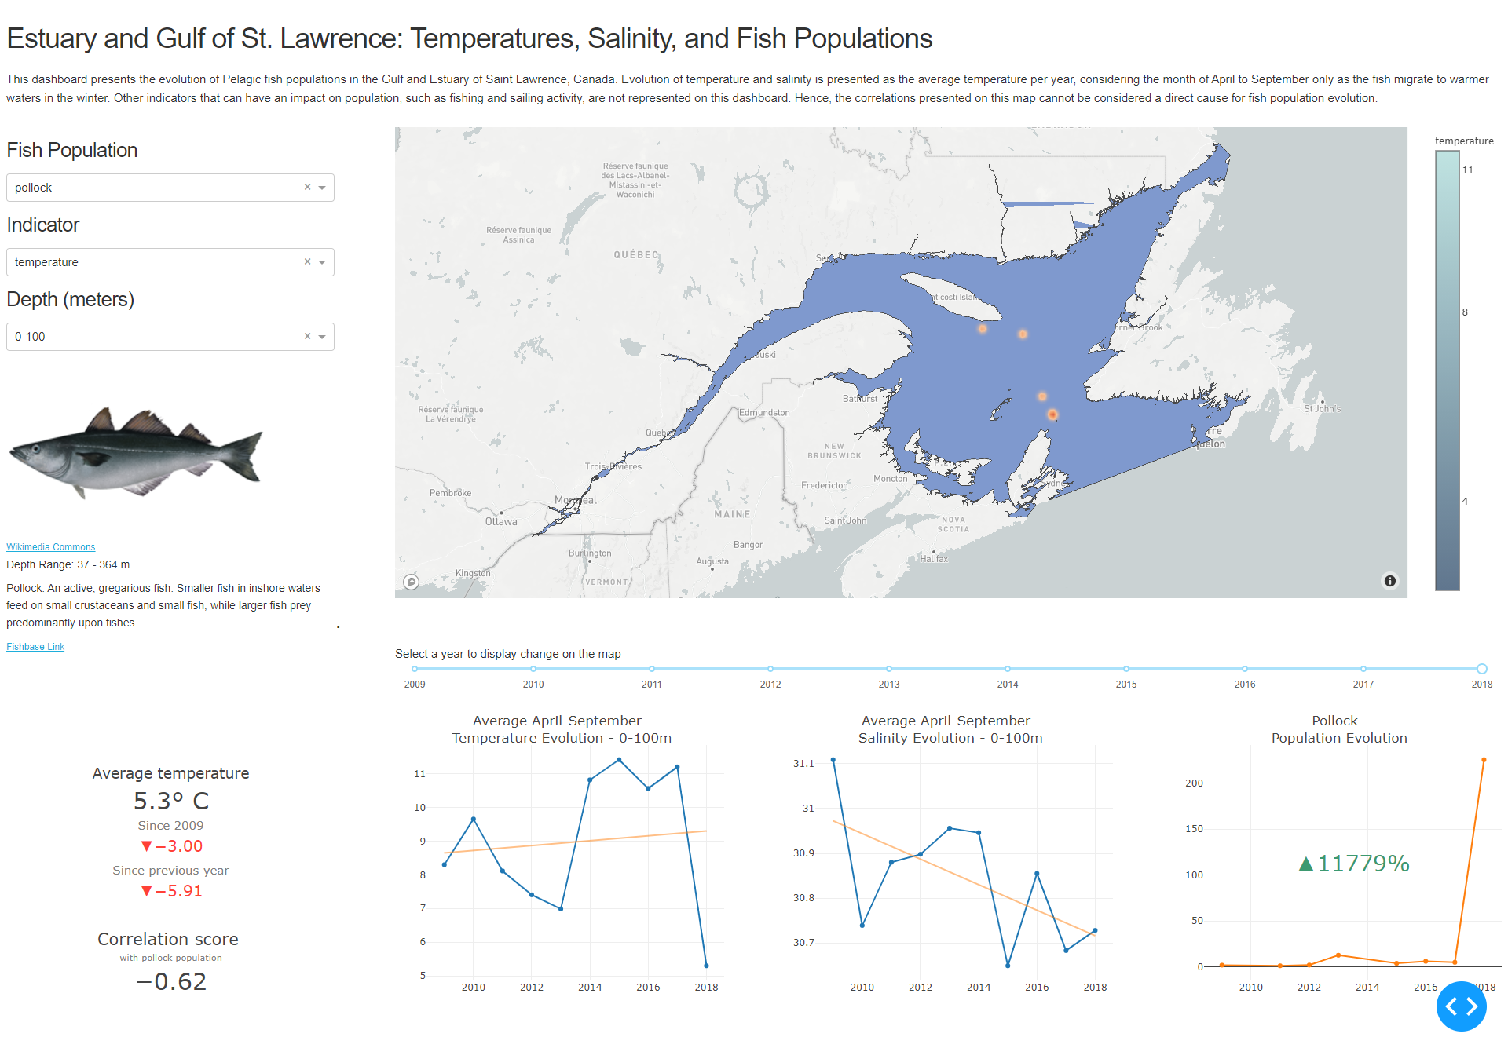

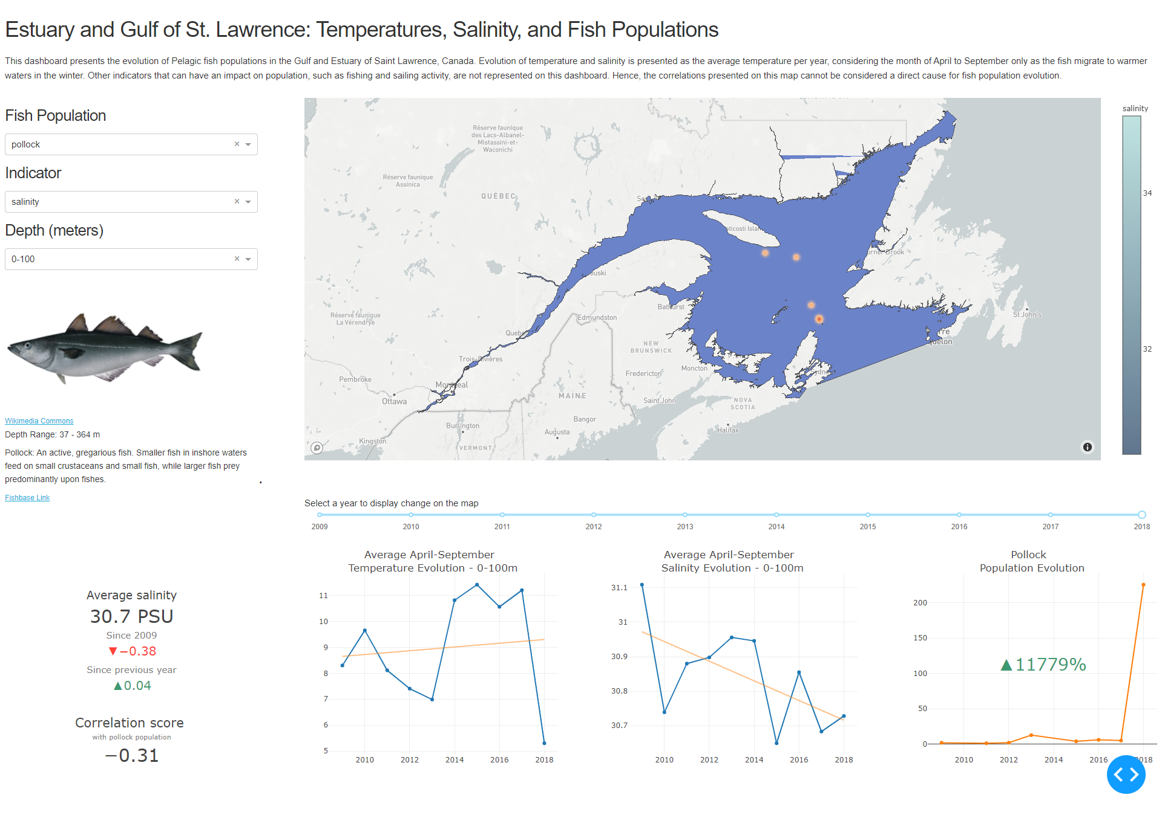

Another interesting study is that of temperature and salinity evolution. While we are familiar with reports of ocean temperatures rising, the pattern varies by depth and location. But we can still see a clear rising pattern. Knowing that an increase in temperature as small as 0.1 degree Celsius can have drastic consequences on the sea fauna and flora, it is concerning to see an increase above 0.5 degrees across all depth intervals, except for the surface area. While surface water temperature is more prone to volatility as it is impacted by air temperature, we see a sharp increase for all depth lower than 100m. This may mean that despite some colder years at the surface, the overall sea water temperatures are rising. More research would need to be done on currents and their impact on temperature, as well as other factors of global warming, to better forecast the evolution of temperature in the future.

# Statement of Work

5. Statement of Work (0 points)

Claire-Isabelle Carlier was the subject matter expert and led in setting up the AWS RDS database. She cleaned and uploaded the Argo data to the database, worked on the advanced visualizations with Dash, and analyzed the results of our correlations in the report.

Sharon Sung wrote the helper files (db.py, spkly), uploaded all datafiles except for Argo float data to AWS RDS, and mapped all the data, inclusive of Argo, to the Estuary and Gulf of St. Lawrence. She also wrote the initial Dash skeleton of the visualization and set up the requirements.txt file and containers for Heroku to host the Dash visualization.

Both looked for and acquired the datasets used for the project.

1. <https://www.dfo-mpo.gc.ca/stats/trade-commerce/world-mondial/export/wxv1517-eng.htm>
2. <https://www.britannica.com/science/seawater/Density-of-seawater-and-pressure>
3. <https://www.fishbase.se/search.php>